Infrared Thermometer
# Source: AI Source: Provided by: [Data Path: Persons Table -> ID Column: 1, Name_En Column: Motasem Essam] -> From: [ChatGPT] on [7/17/2026]
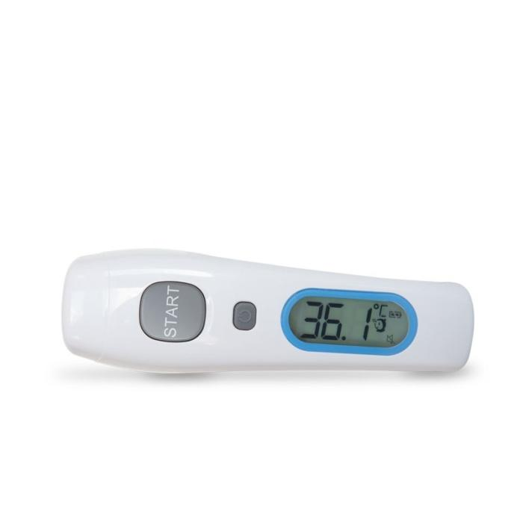
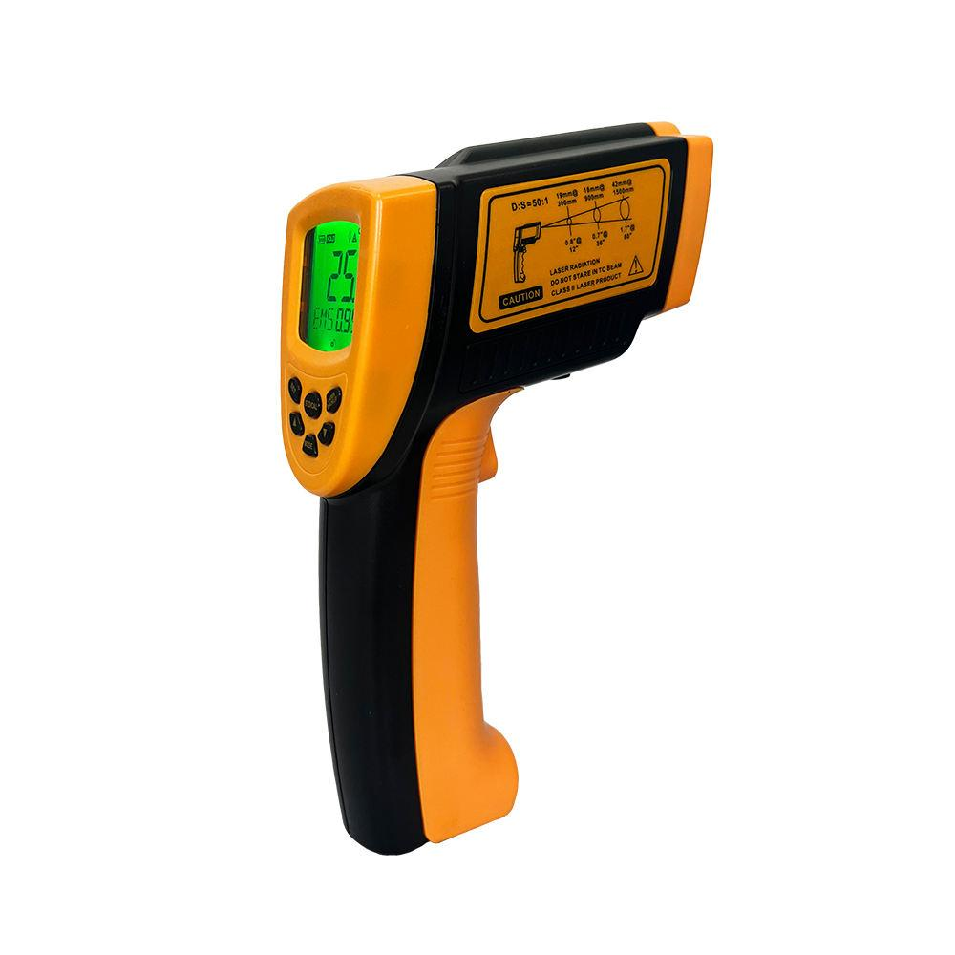
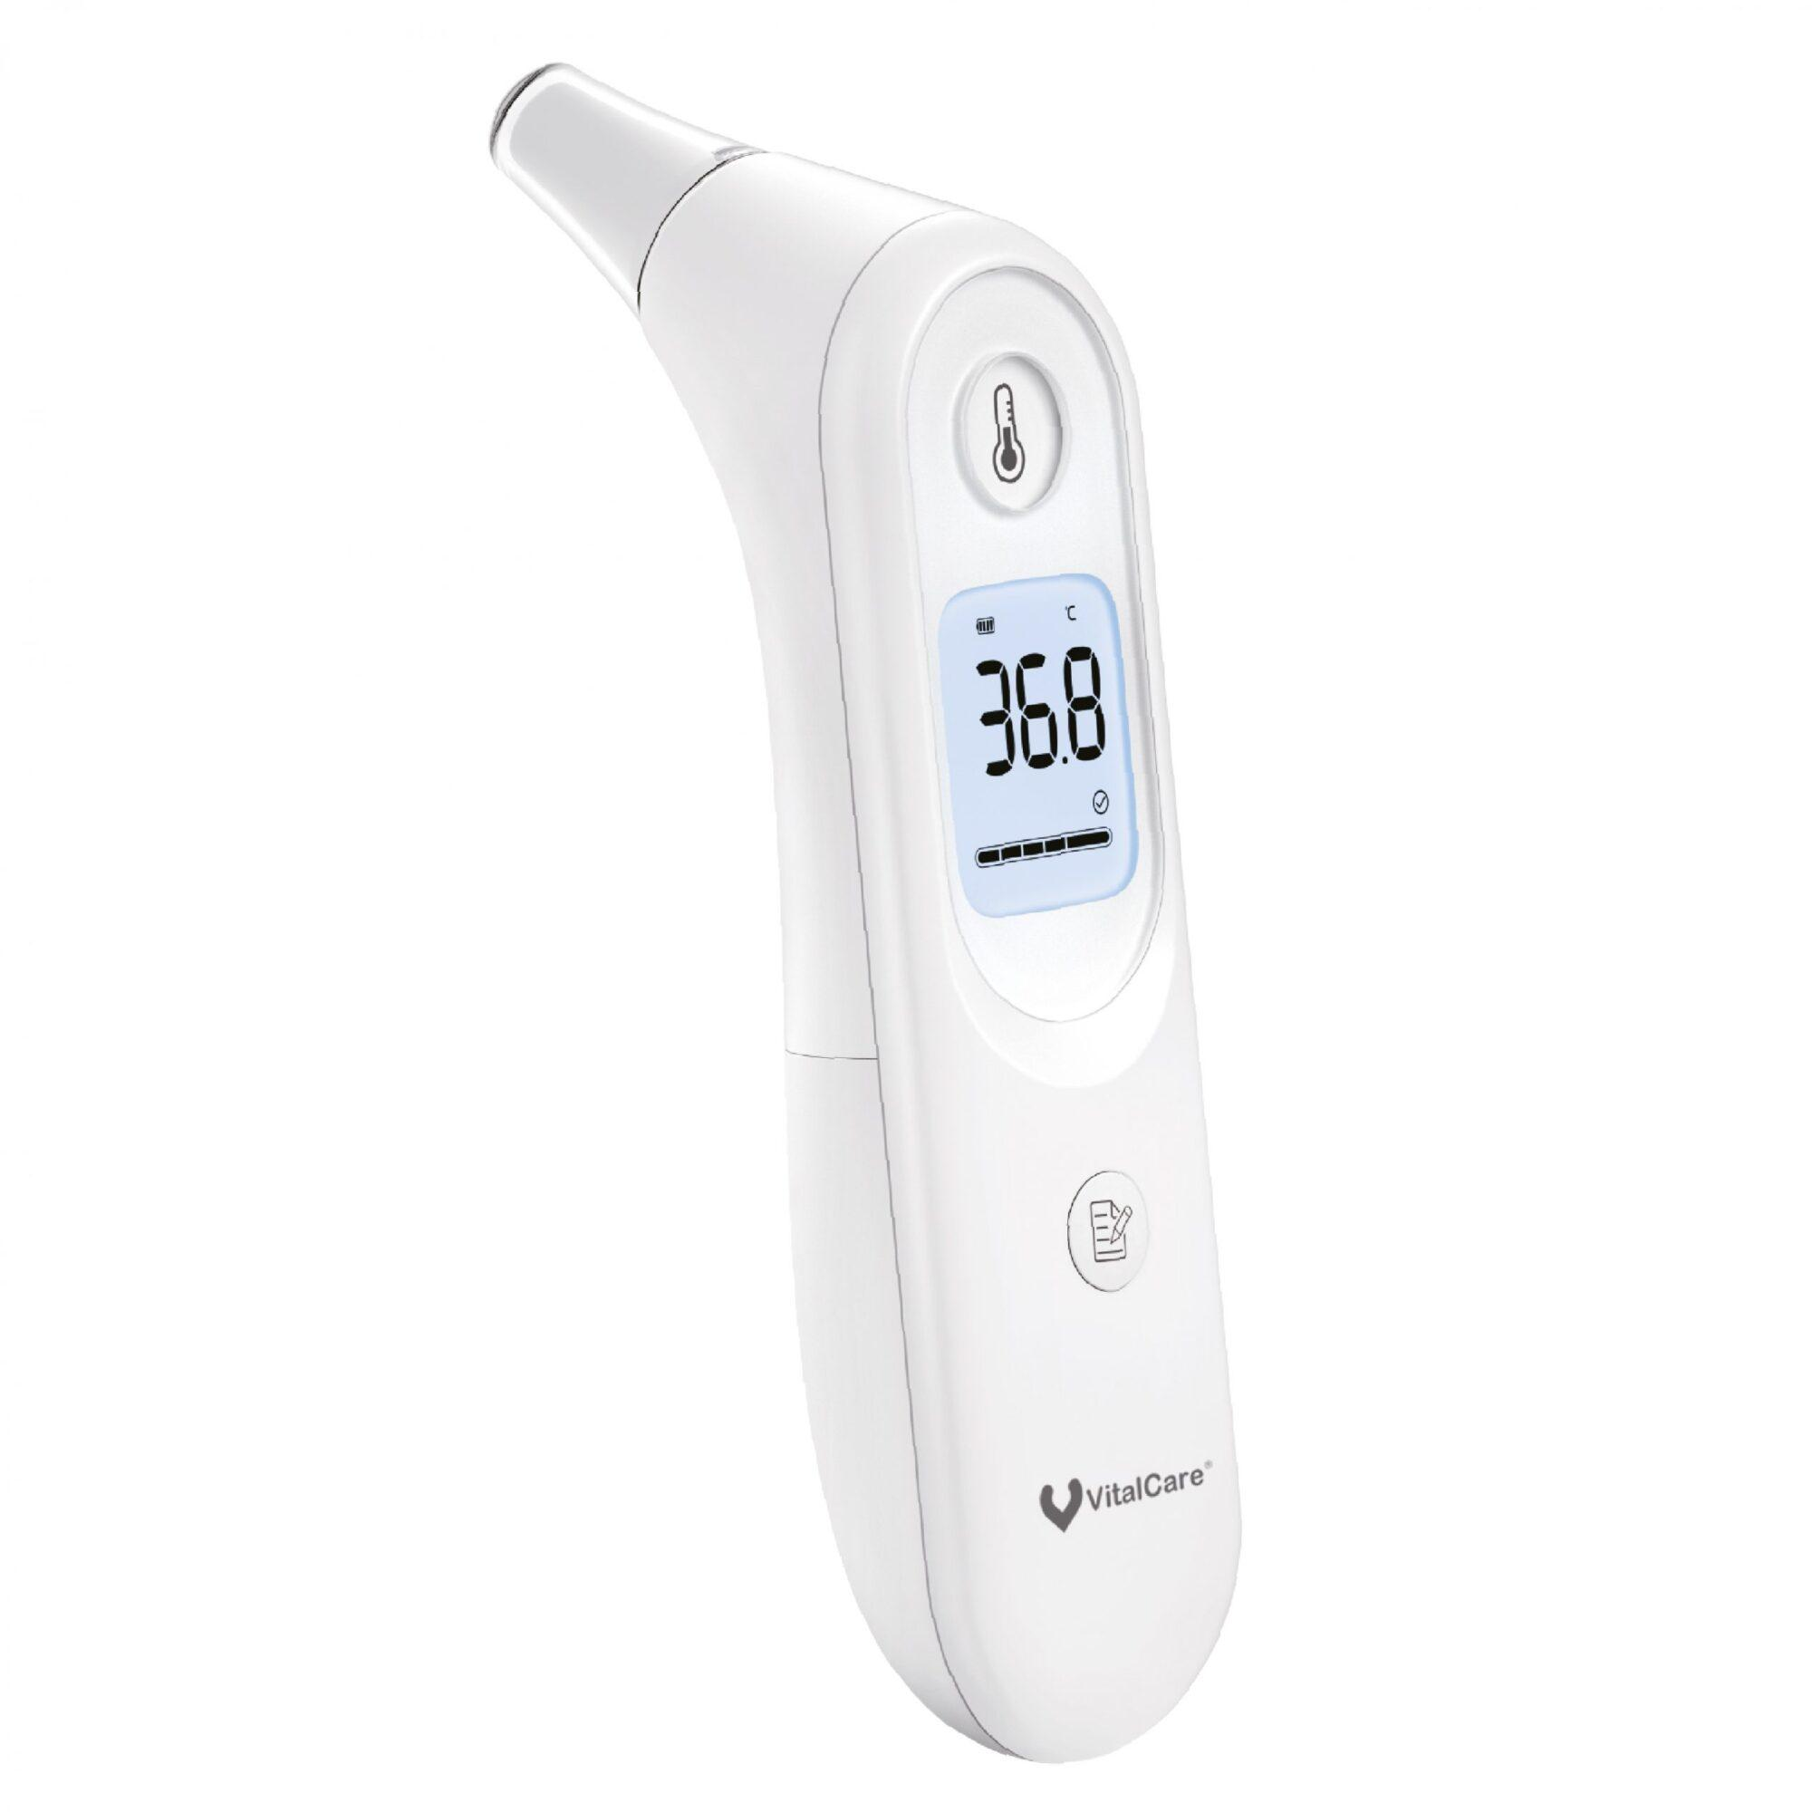
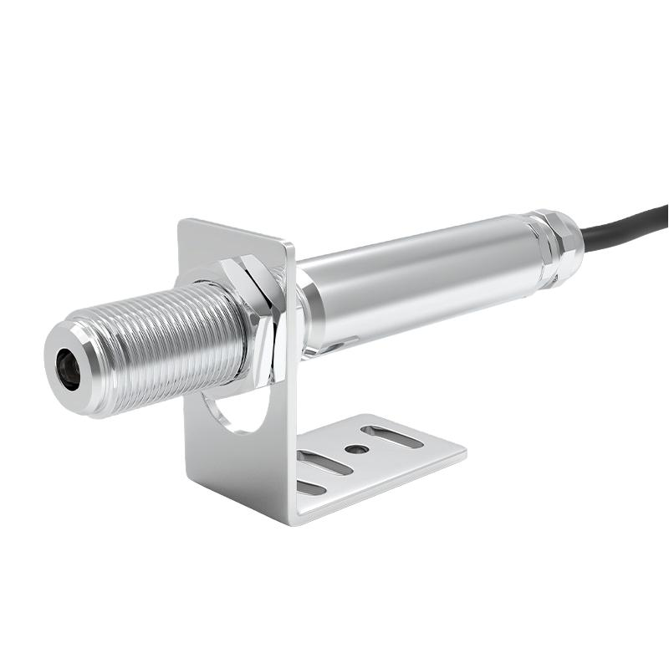
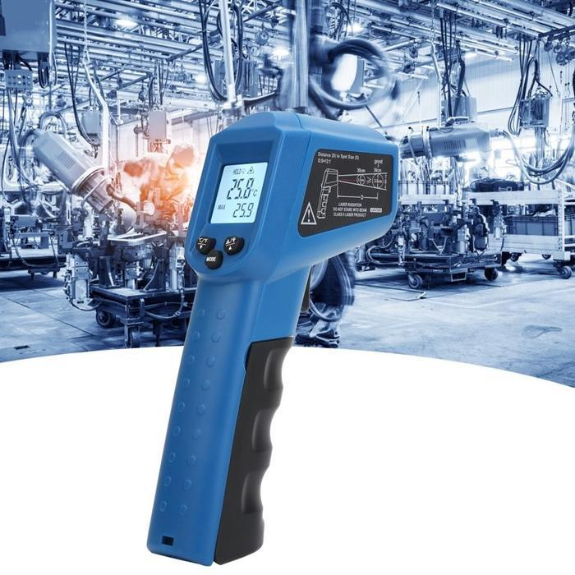
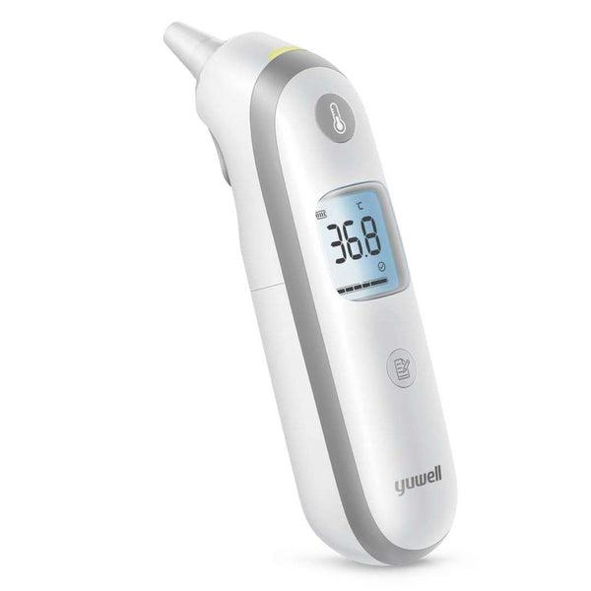
An Infrared Thermometer (IR Thermometer) is a non-contact temperature-measuring instrument that determines the temperature of an object by detecting the infrared (thermal) radiation emitted from its surface. Unlike contact thermometers, it measures temperature without physically touching the object, making it ideal for moving, hazardous, extremely hot, sterile, or difficult-to-reach targets.
Infrared thermometers are widely used in medicine, manufacturing, food safety, electrical maintenance, HVAC, laboratories, automotive industries, and scientific research.

Definition
# Source: AI Source: Provided by: [Data Path: Persons Table -> ID Column: 1, Name_En Column: Motasem Essam] -> From: [ChatGPT] on [7/17/2026]
An Infrared Thermometer is a non-contact electronic temperature-measuring instrument that determines temperature by detecting infrared radiation emitted from an object's surface.

Purpose
# Source: AI Source: Provided by: [Data Path: Persons Table -> ID Column: 1, Name_En Column: Motasem Essam] -> From: [ChatGPT] on [7/17/2026]
An infrared thermometer is used to:
- Measure surface temperature.
- Measure body temperature without contact.
- Monitor industrial equipment.
- Check electrical components.
- Inspect HVAC systems.
- Measure food temperatures.
- Detect overheating equipment.
- Monitor hazardous materials.

Principle of Operation
# Source: AI Source: Provided by: [Data Path: Persons Table -> ID Column: 1, Name_En Column: Motasem Essam] -> From: [ChatGPT] on [7/17/2026]
Every object above absolute zero (0 K) emits infrared radiation.
The infrared thermometer:
- Detects the emitted infrared energy.
- Focuses it onto an infrared sensor.
- Converts the infrared energy into an electrical signal.
- Calculates the object's temperature.
- Displays the result digitally.
Unlike contact thermometers, it measures surface temperature only.

Main Components
# Source: AI Source: Provided by: [Data Path: Persons Table -> ID Column: 1, Name_En Column: Motasem Essam] -> From: [ChatGPT] on [7/17/2026]
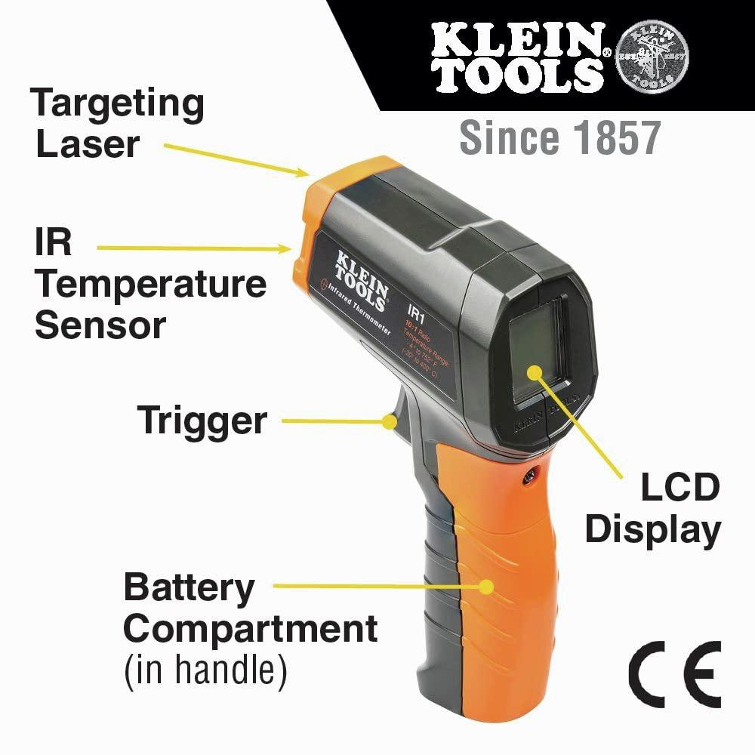
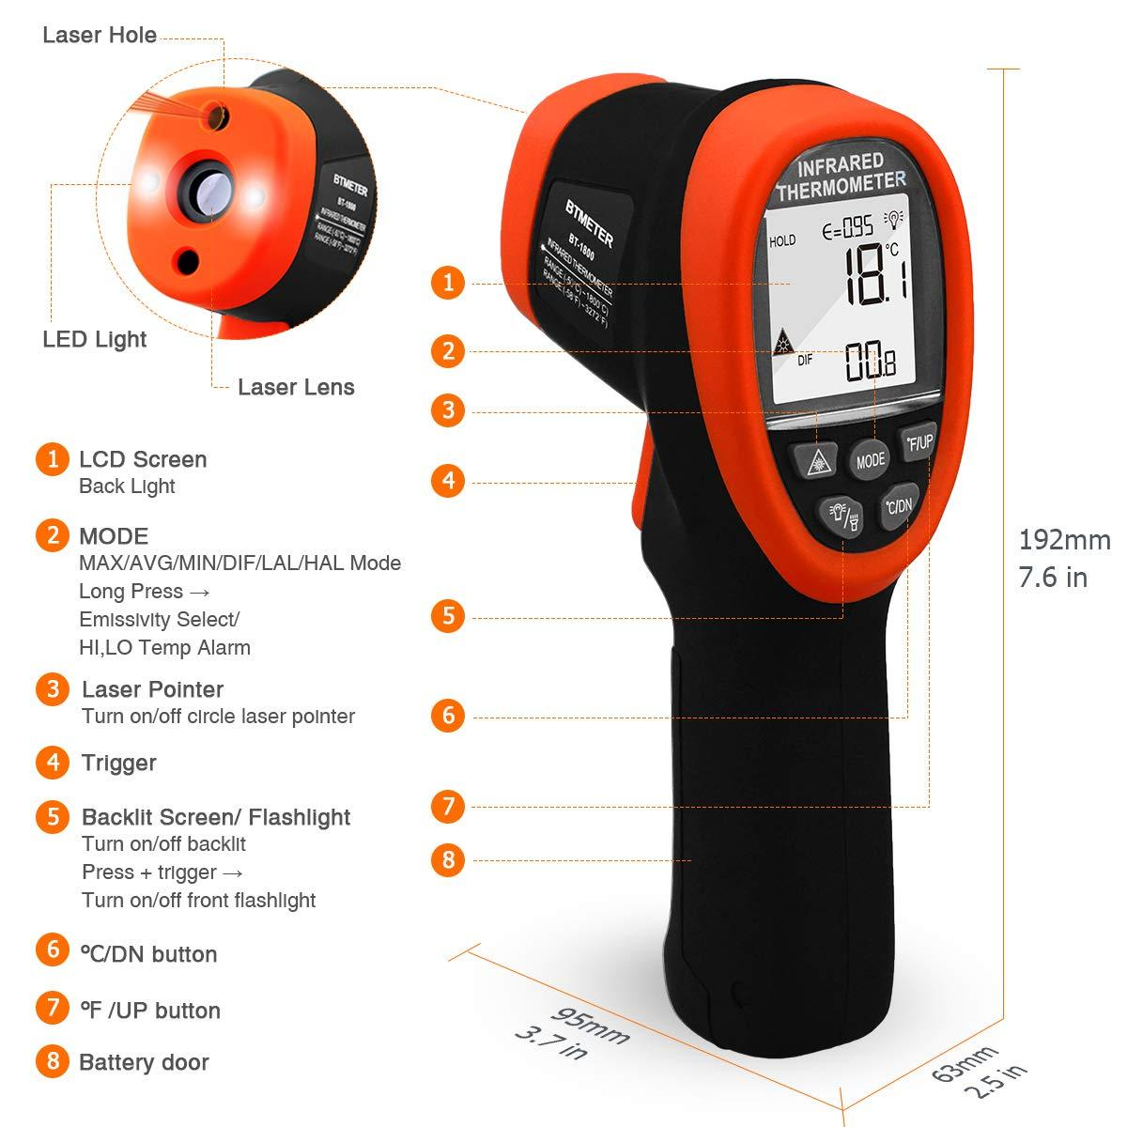
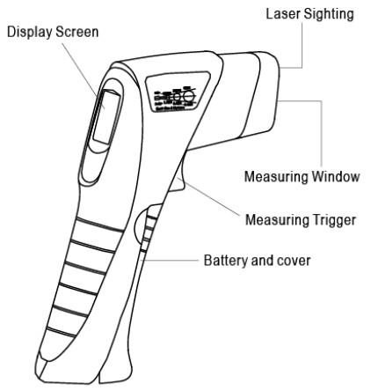
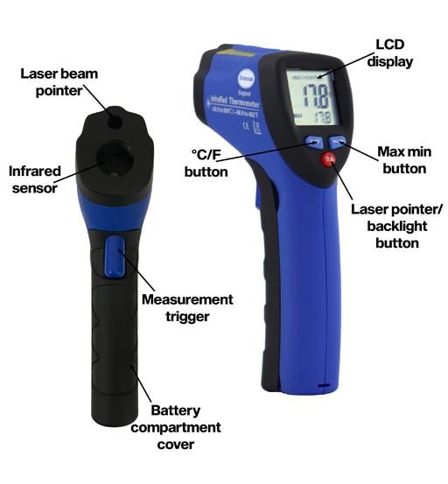
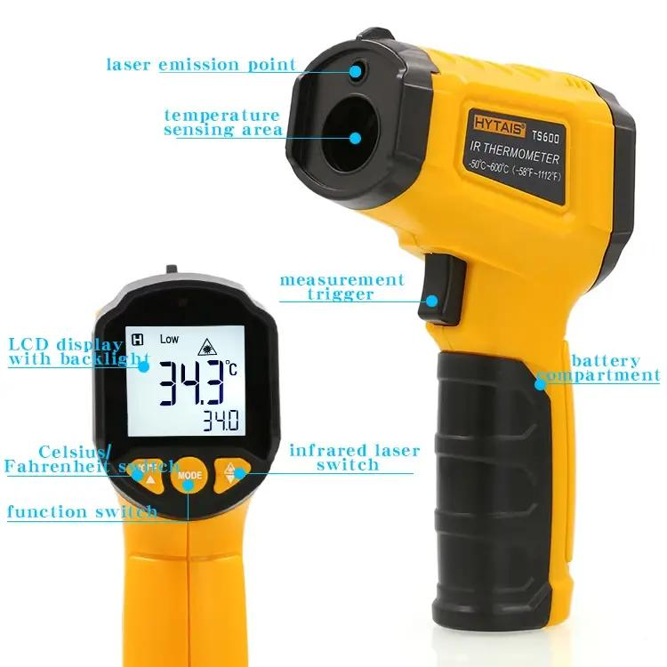
A typical infrared thermometer consists of:
- Infrared sensor
- Optical lens
- Laser pointer (many industrial models)
- Digital display (LCD)
- Trigger button
- Electronic processor
- Battery compartment

Types of Infrared Thermometers

1. Medical Forehead Infrared Thermometer
# Source: AI Source: Provided by: [Data Path: Persons Table -> ID Column: 1, Name_En Column: Motasem Essam] -> From: [ChatGPT] on [7/17/2026]
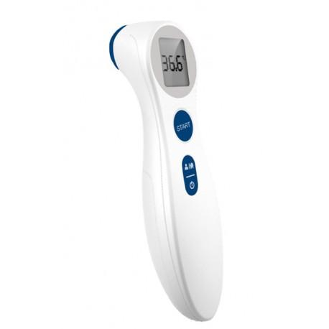
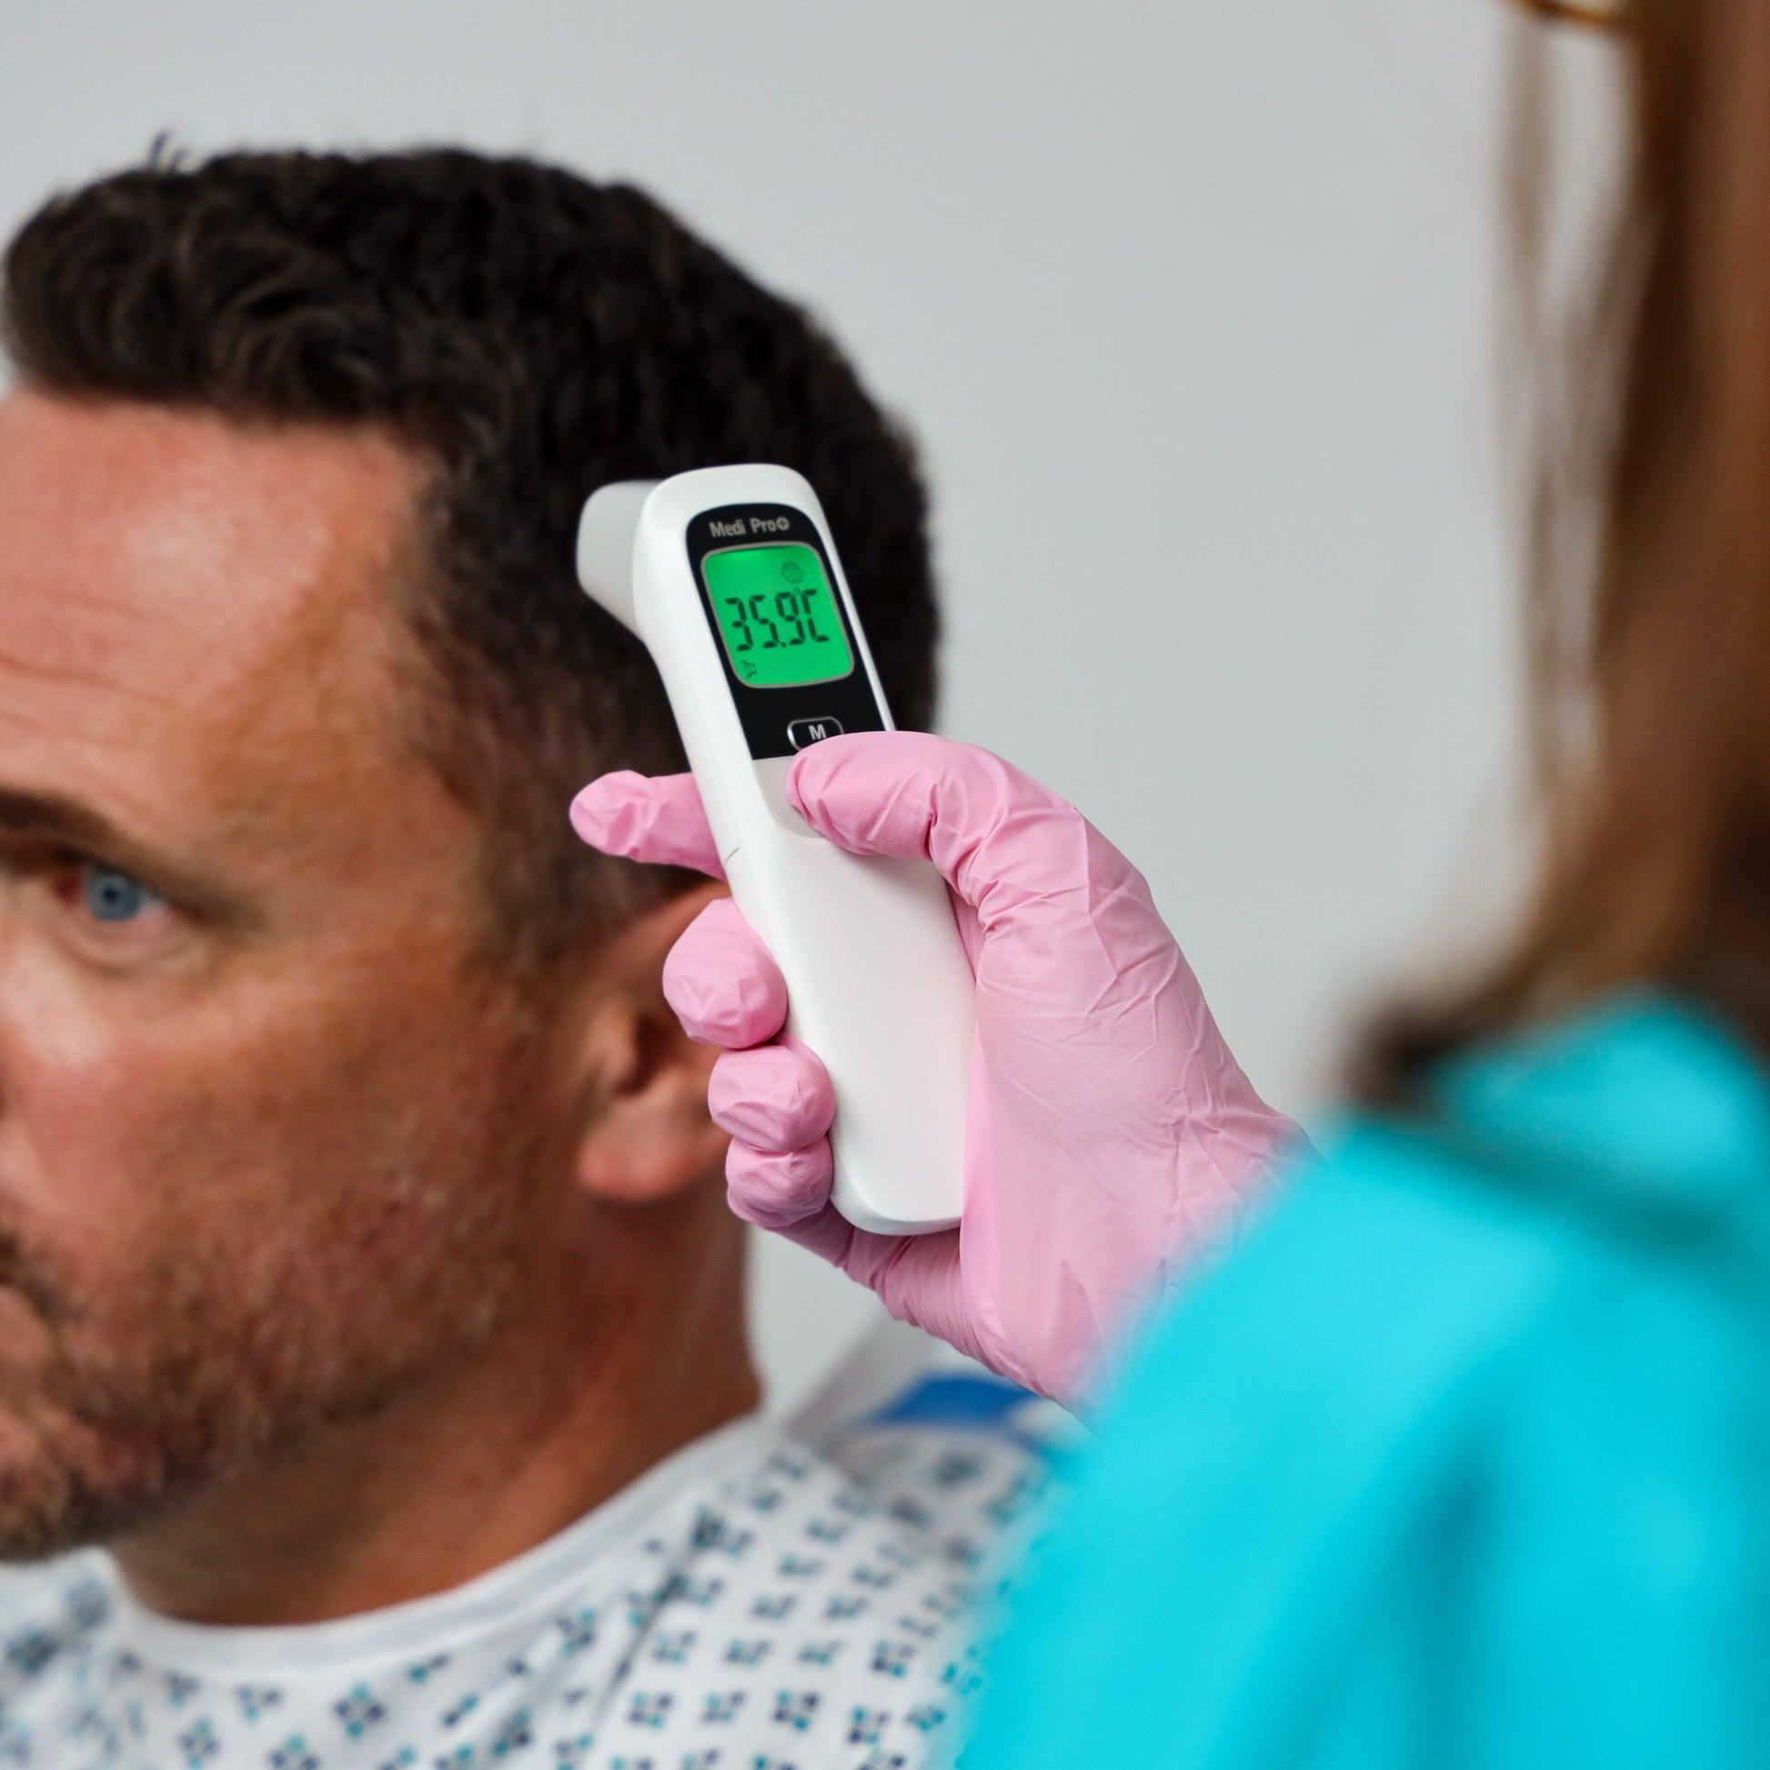
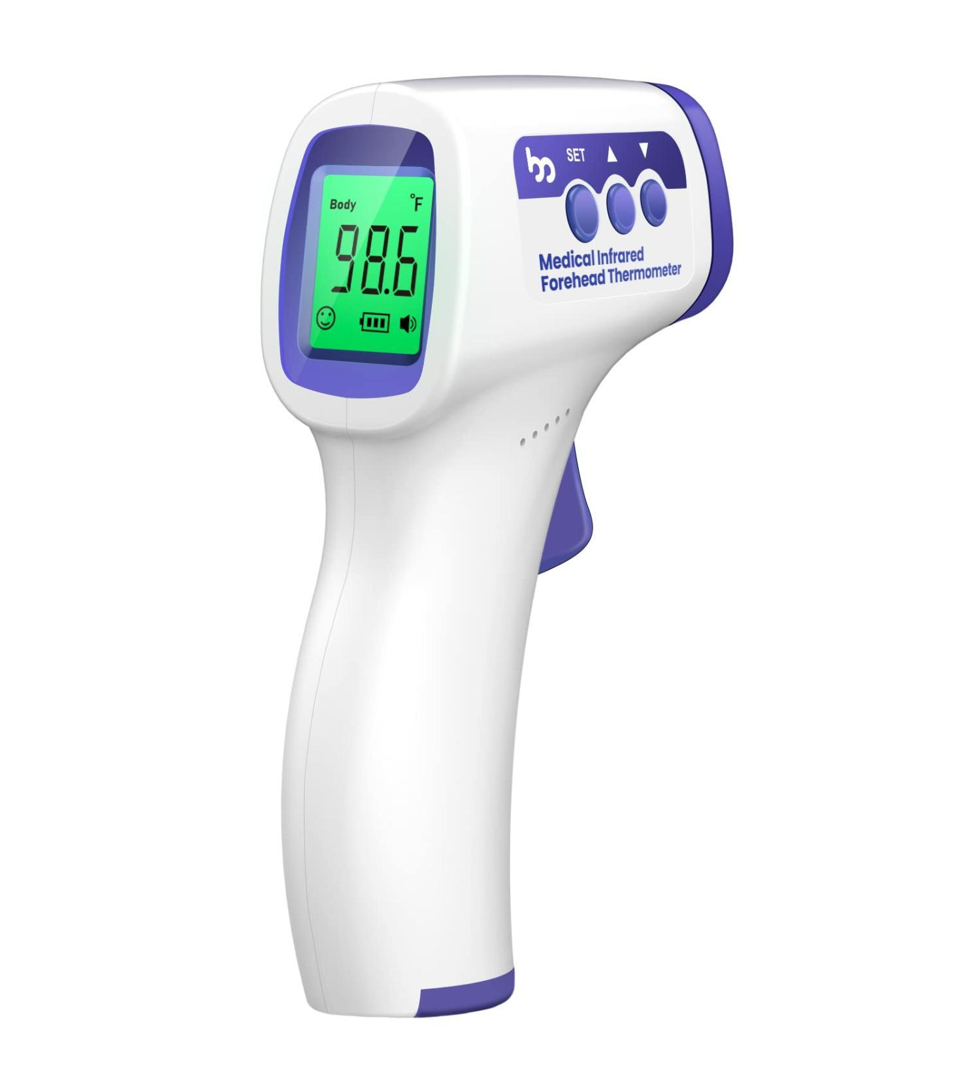
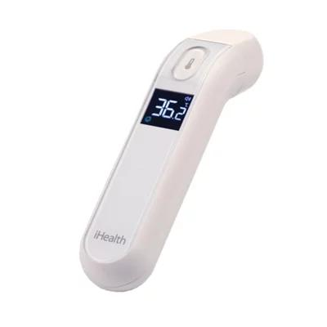
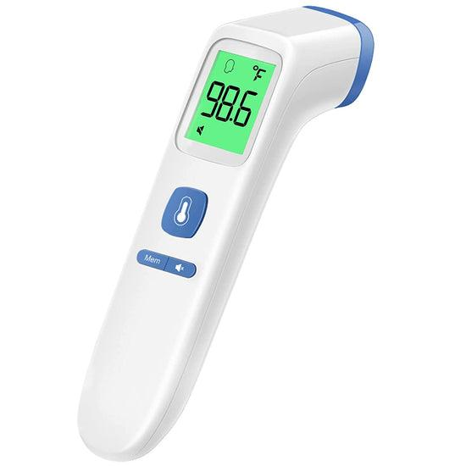
Description
Designed to measure human body temperature without touching the skin by detecting infrared radiation emitted from the forehead.
Features
- Non-contact measurement
- Fast reading (typically 1–3 seconds)
- Hygienic
- Easy to use
Applications
- Hospitals
- Clinics
- Home healthcare
- Disease screening

2. Infrared Ear Thermometer (Tympanic Thermometer)
# Source: AI Source: Provided by: [Data Path: Persons Table -> ID Column: 1, Name_En Column: Motasem Essam] -> From: [ChatGPT] on [7/17/2026]
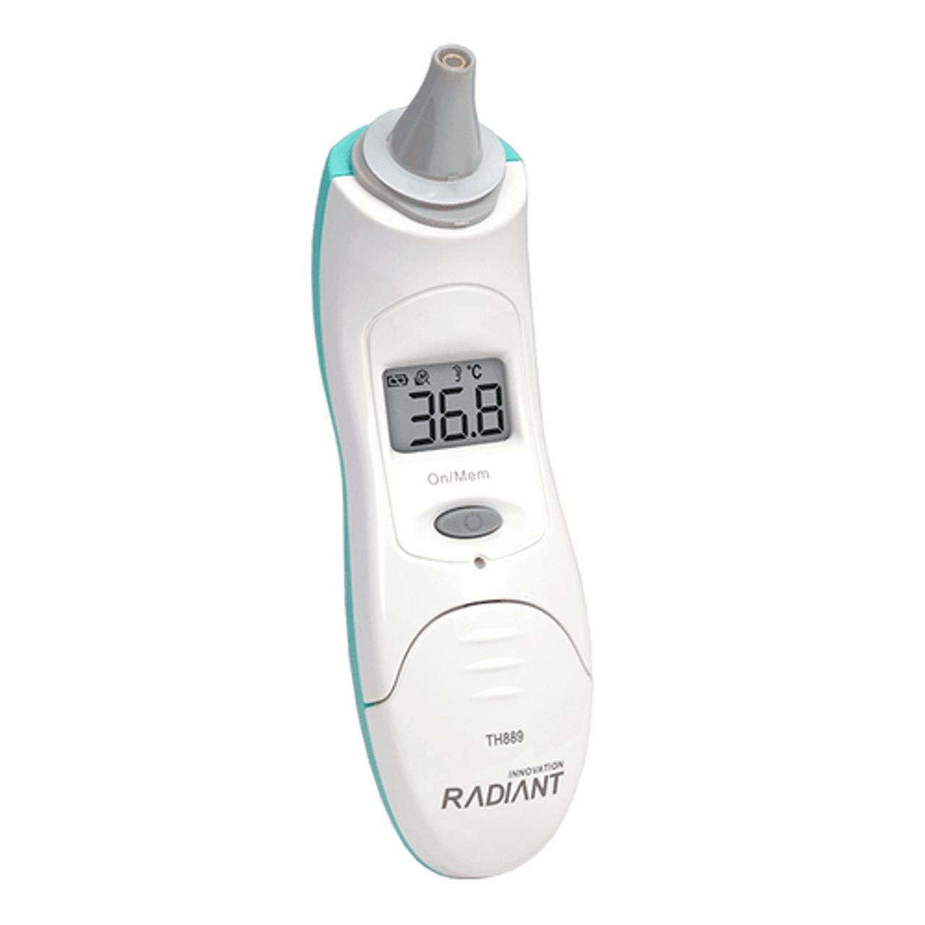
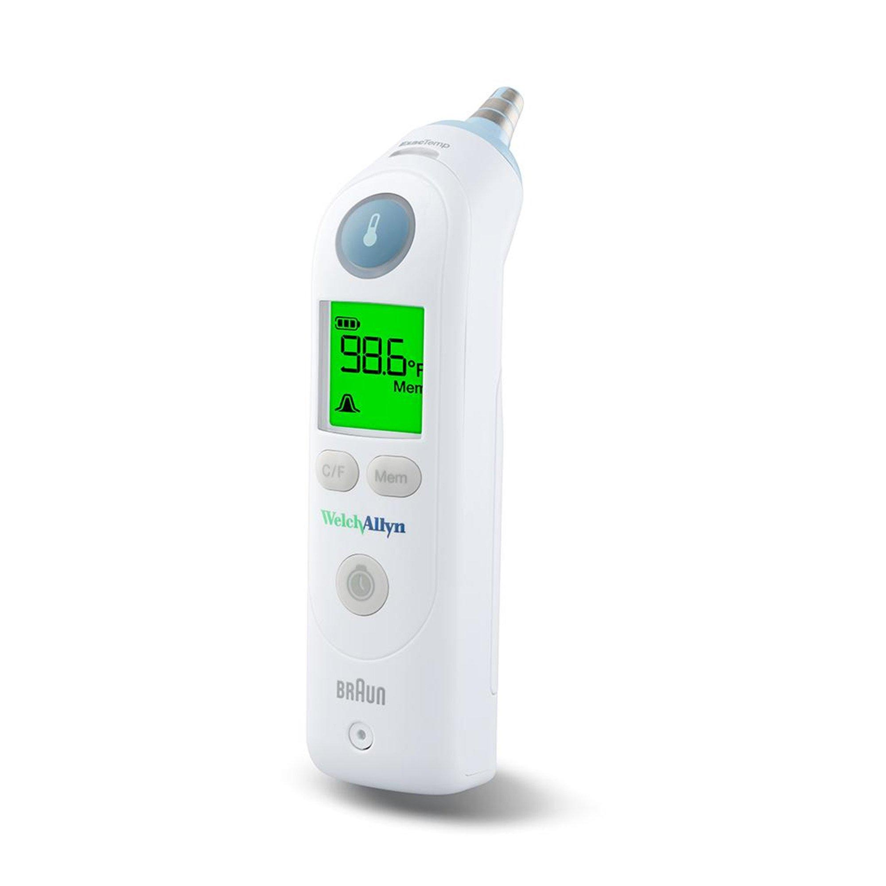
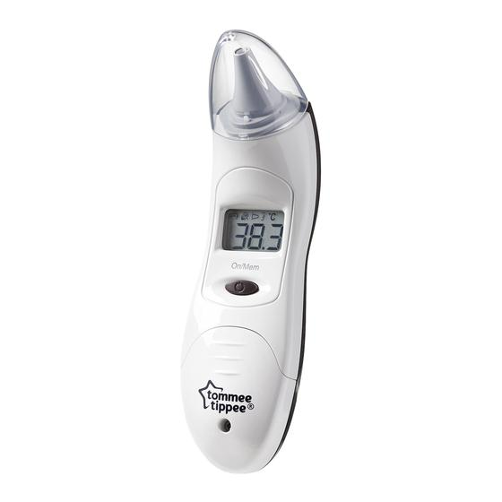
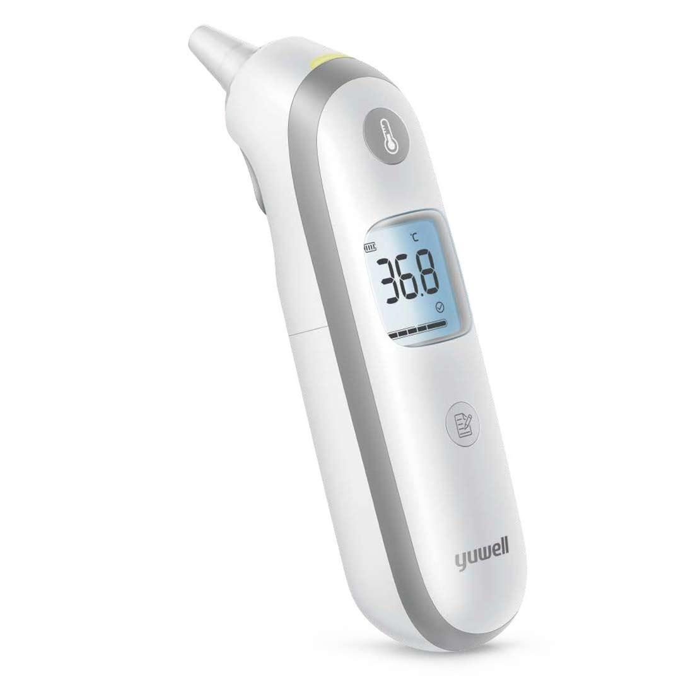
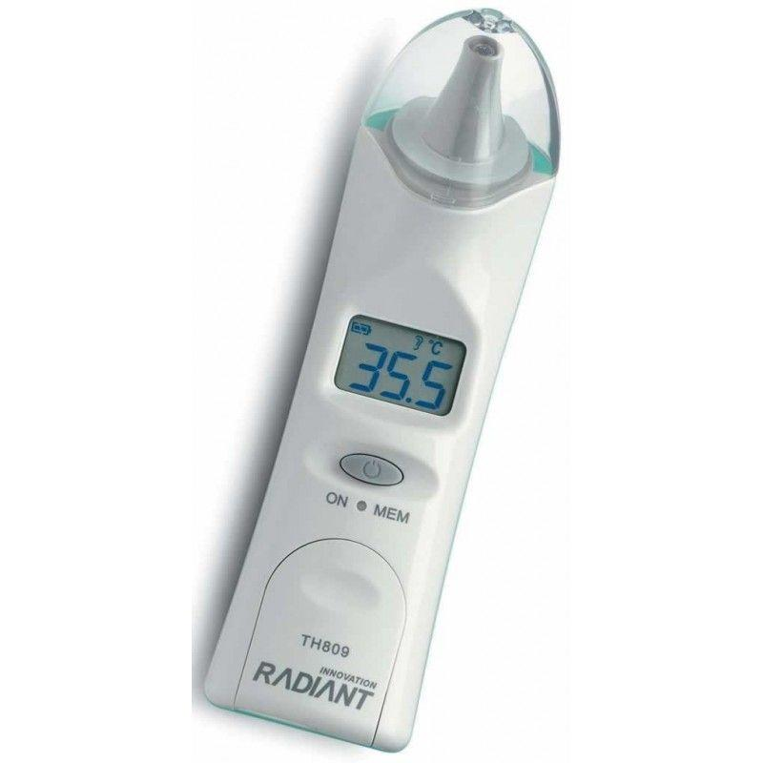
Description
Measures body temperature by detecting infrared radiation emitted from the eardrum (tympanic membrane).
Features
- Very fast measurement
- High medical accuracy
- Small probe with disposable covers
Applications
- Hospitals
- Pediatric care
- Medical clinics
- Home healthcare

3. Industrial Infrared Thermometer (Laser Thermometer)
# Source: AI Source: Provided by: [Data Path: Persons Table -> ID Column: 1, Name_En Column: Motasem Essam] -> From: [ChatGPT] on [7/17/2026]
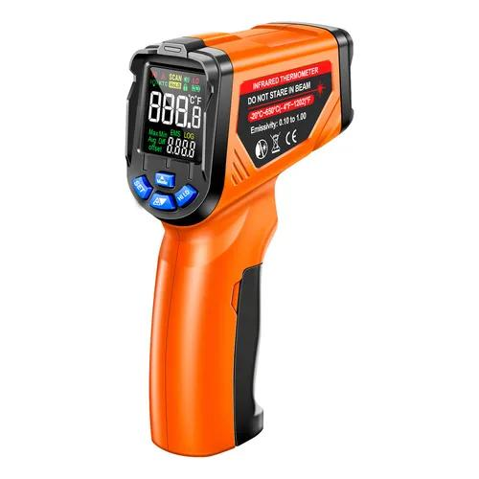
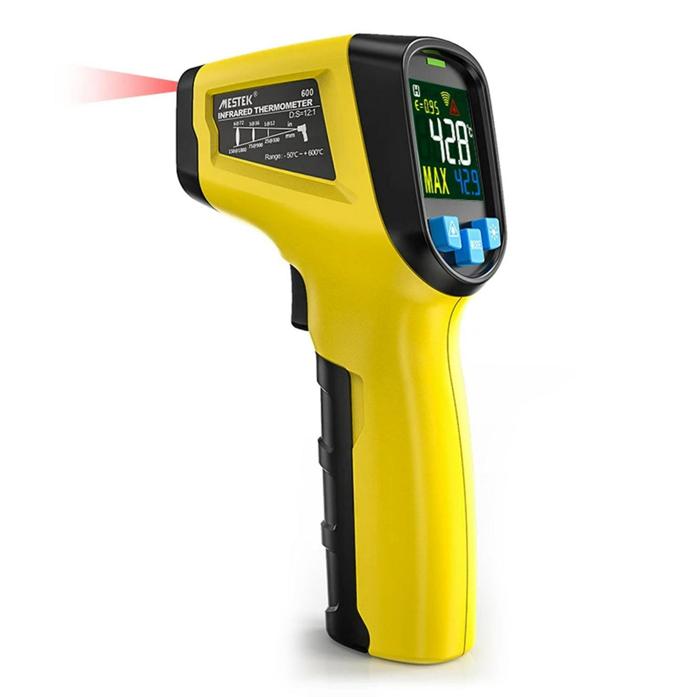
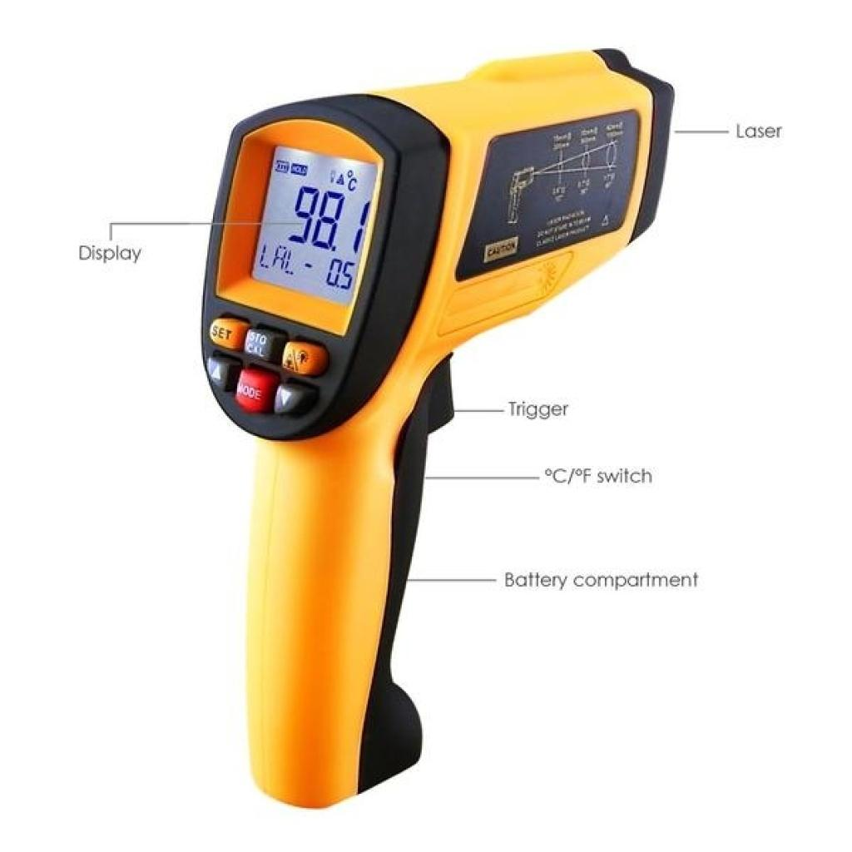
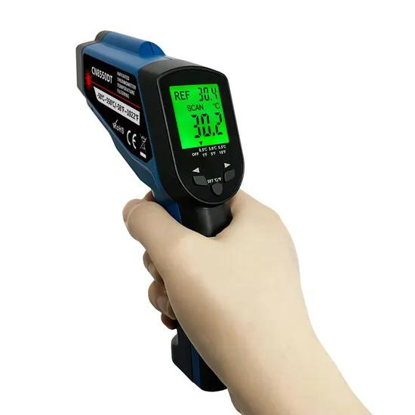
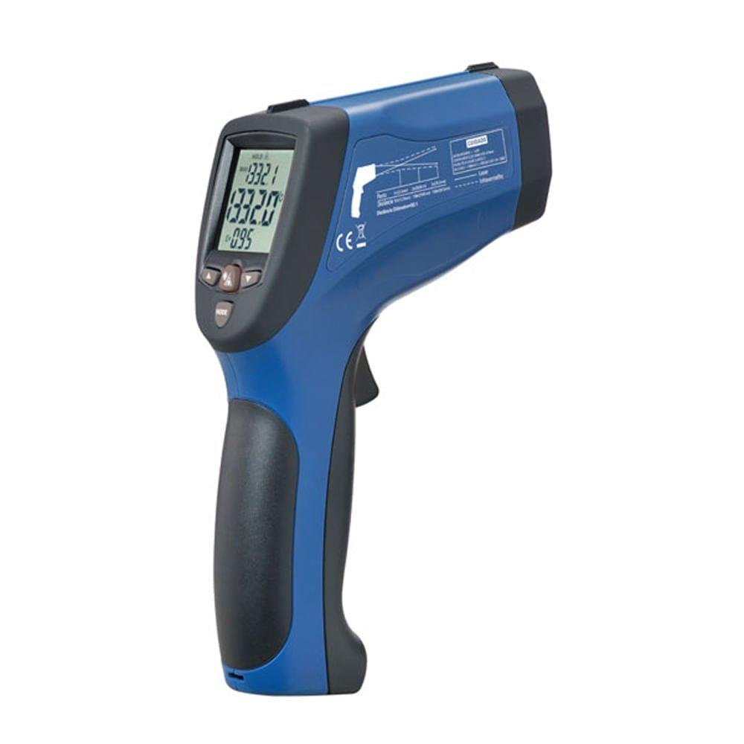
Description
A handheld non-contact thermometer used to measure the surface temperature of machinery, equipment, electrical components, and industrial processes.
Features
- Laser aiming
- Wide temperature range
- Distance-to-Spot (D:S) ratio
- Fast response
Applications
- Manufacturing
- Electrical maintenance
- Mechanical maintenance
- HVAC
- Automotive diagnostics

4. Fixed Infrared Temperature Sensor
# Source: AI Source: Provided by: [Data Path: Persons Table -> ID Column: 1, Name_En Column: Motasem Essam] -> From: [ChatGPT] on [7/17/2026]

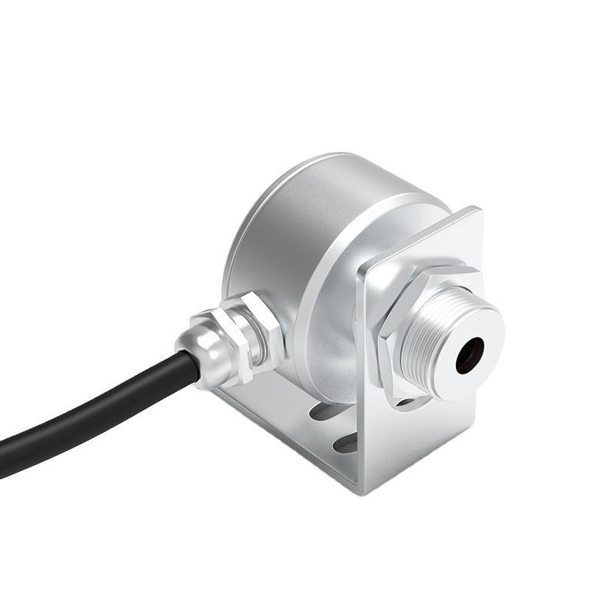
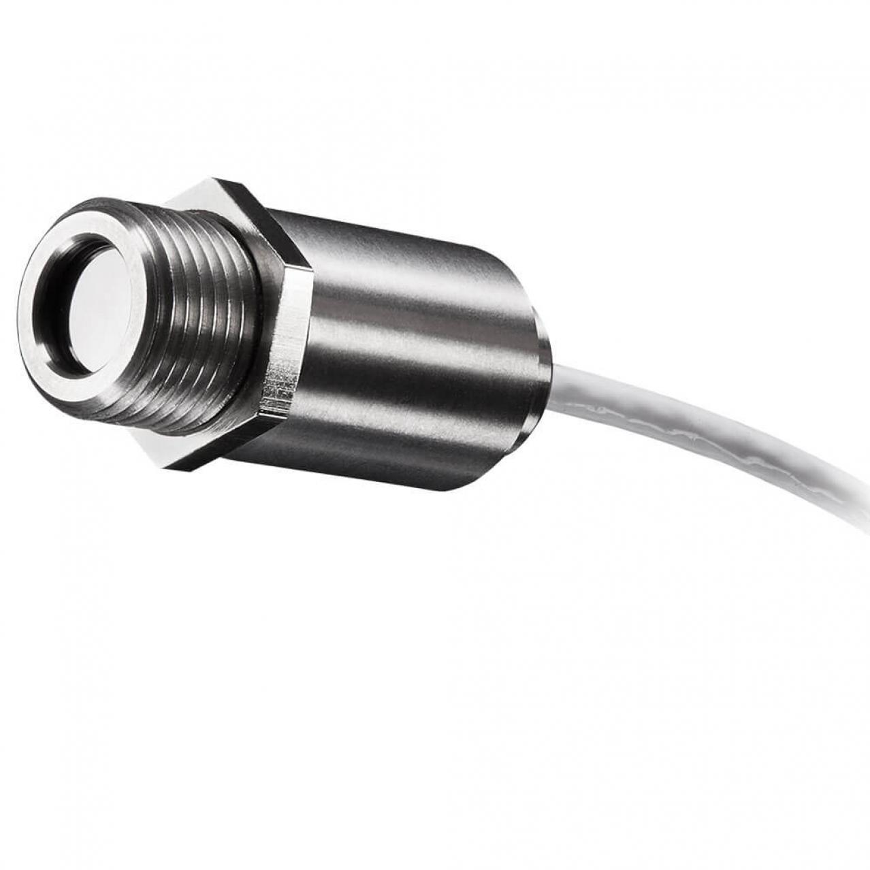
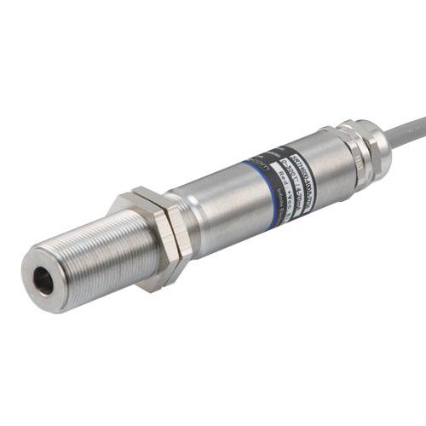
Description
A permanently mounted infrared sensor that continuously monitors the temperature of moving or stationary objects.
Features
- Continuous measurement
- Automatic monitoring
- High repeatability
Applications
- Production lines
- Industrial automation
- Quality control
- Process monitoring

5. Food Infrared Thermometer
# Source: AI Source: Provided by: [Data Path: Persons Table -> ID Column: 1, Name_En Column: Motasem Essam] -> From: [ChatGPT] on [7/17/2026]
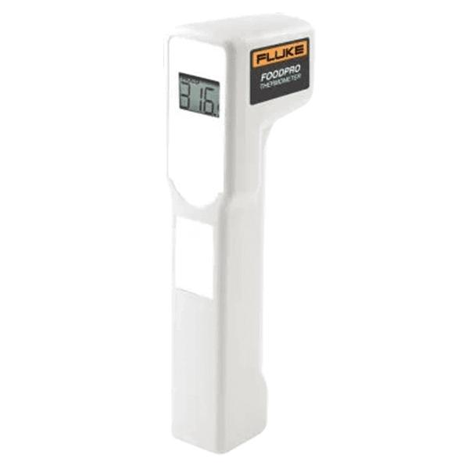
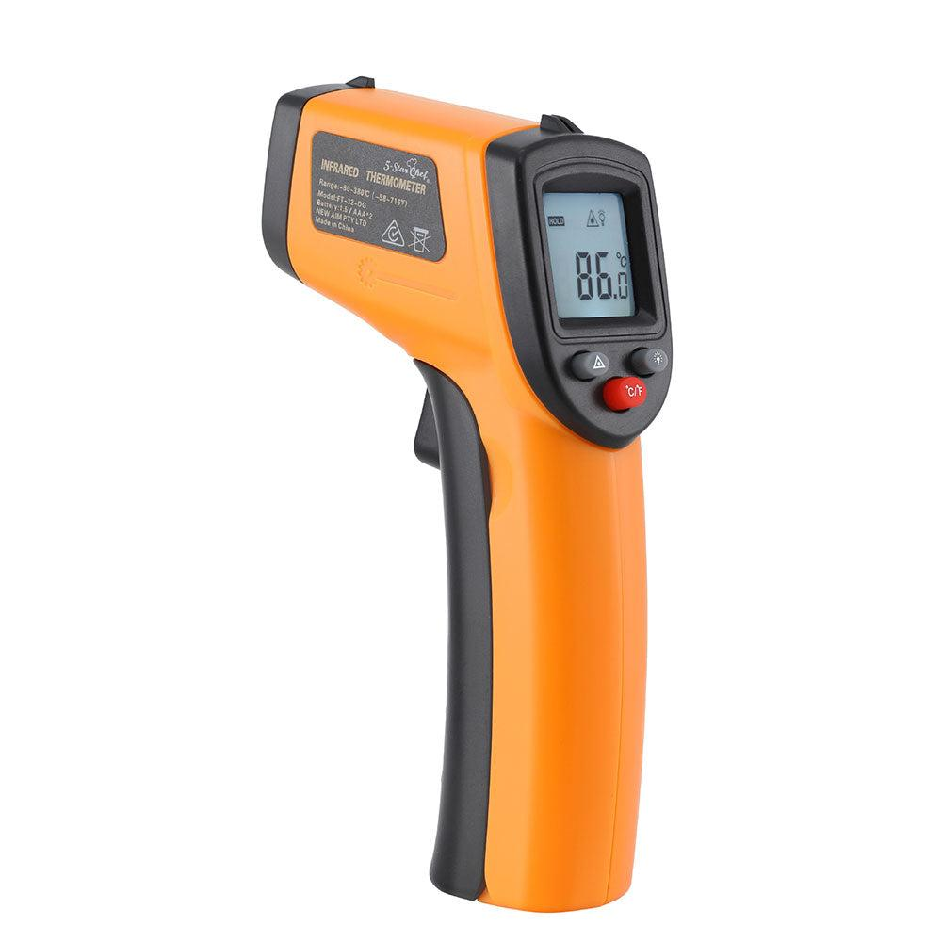
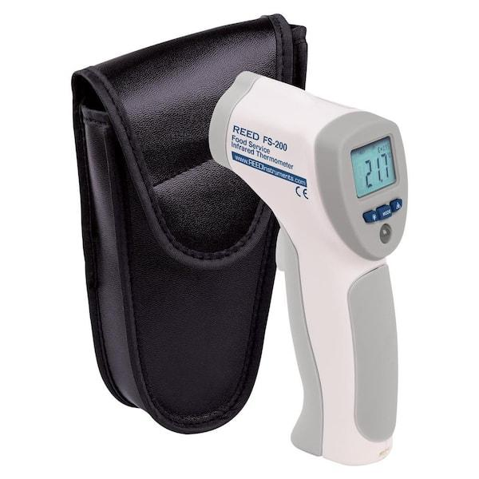
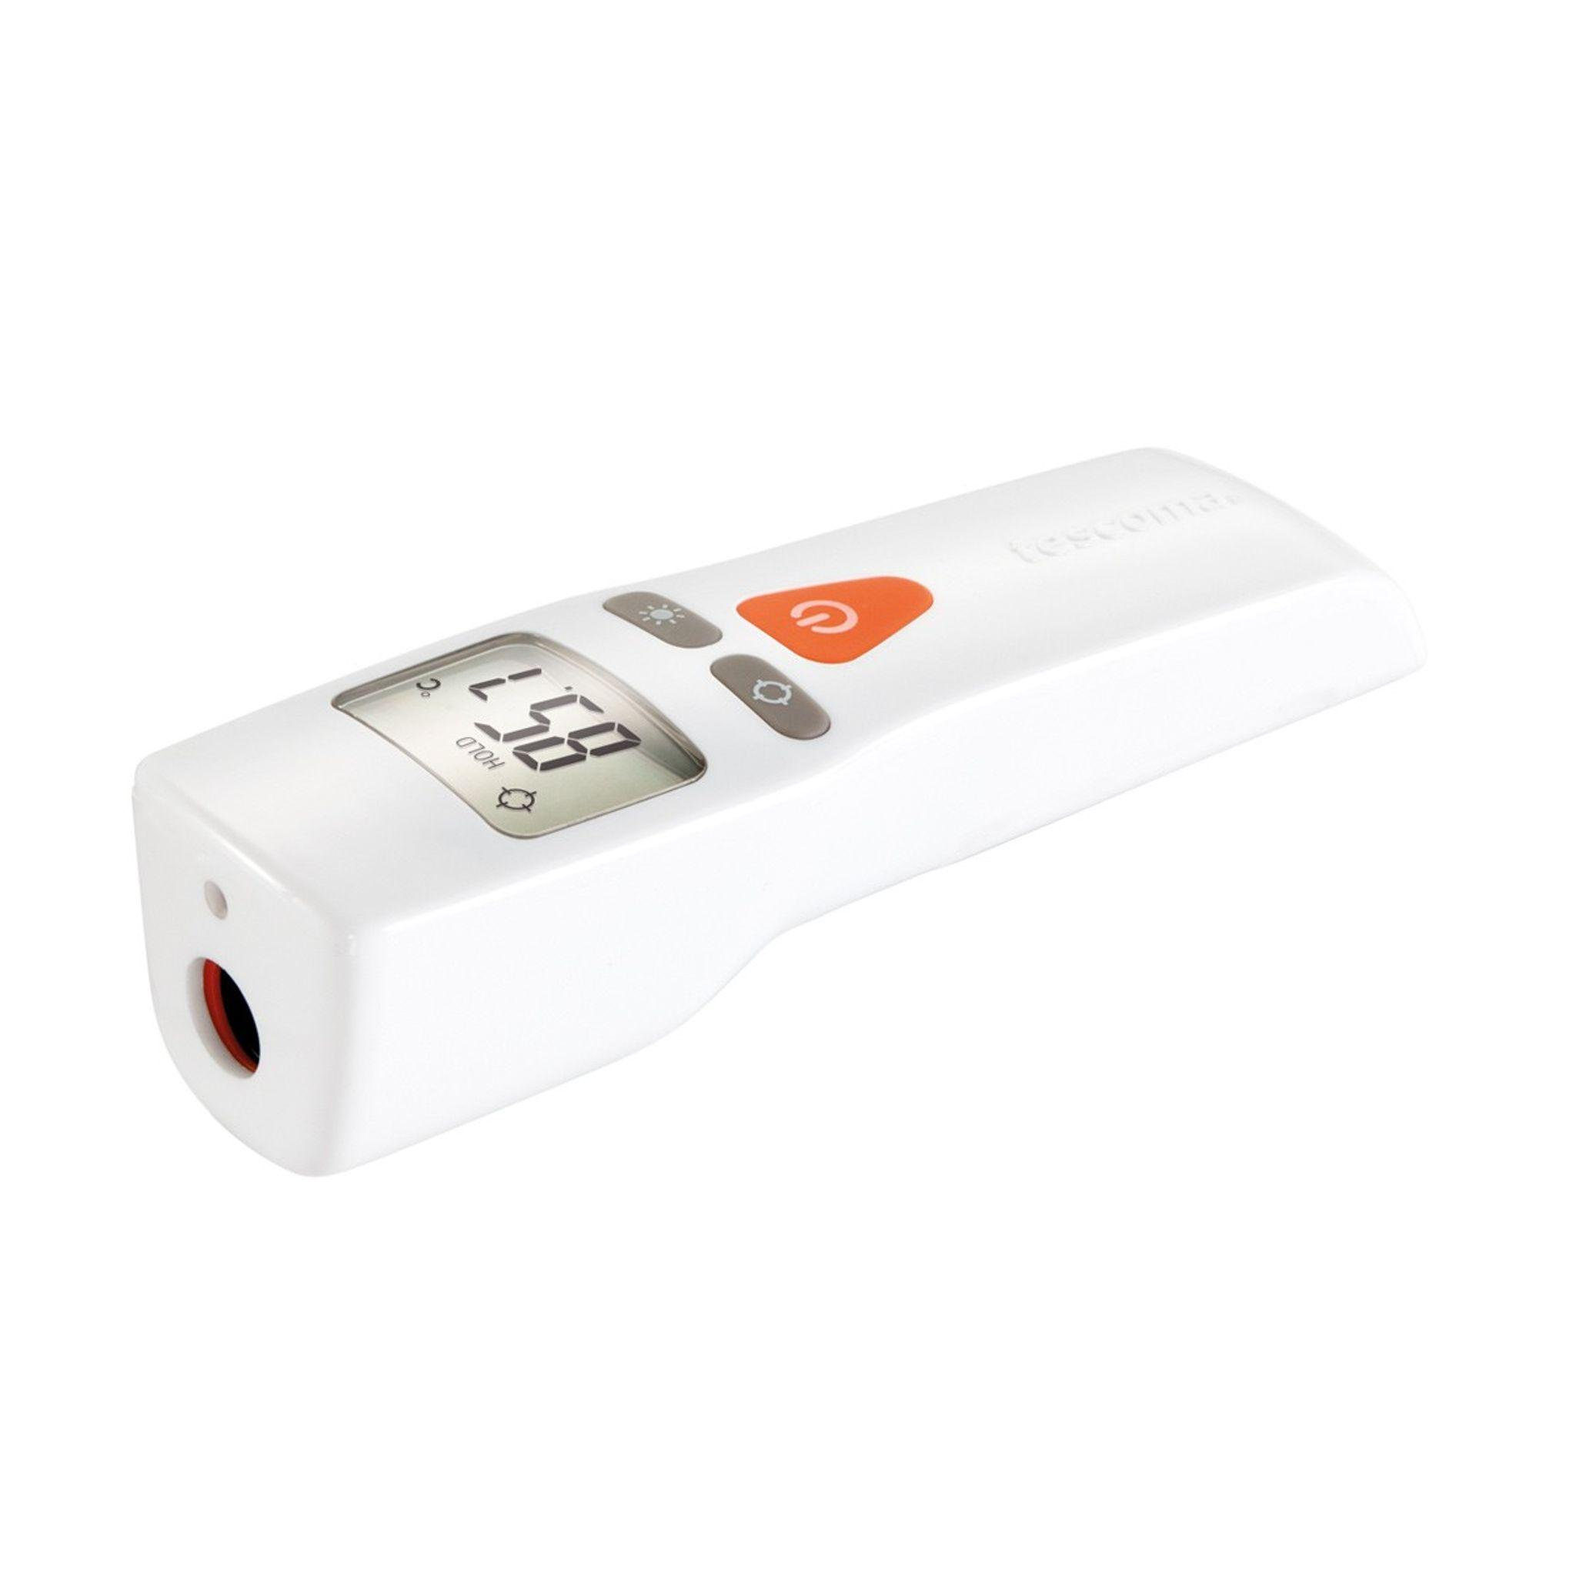
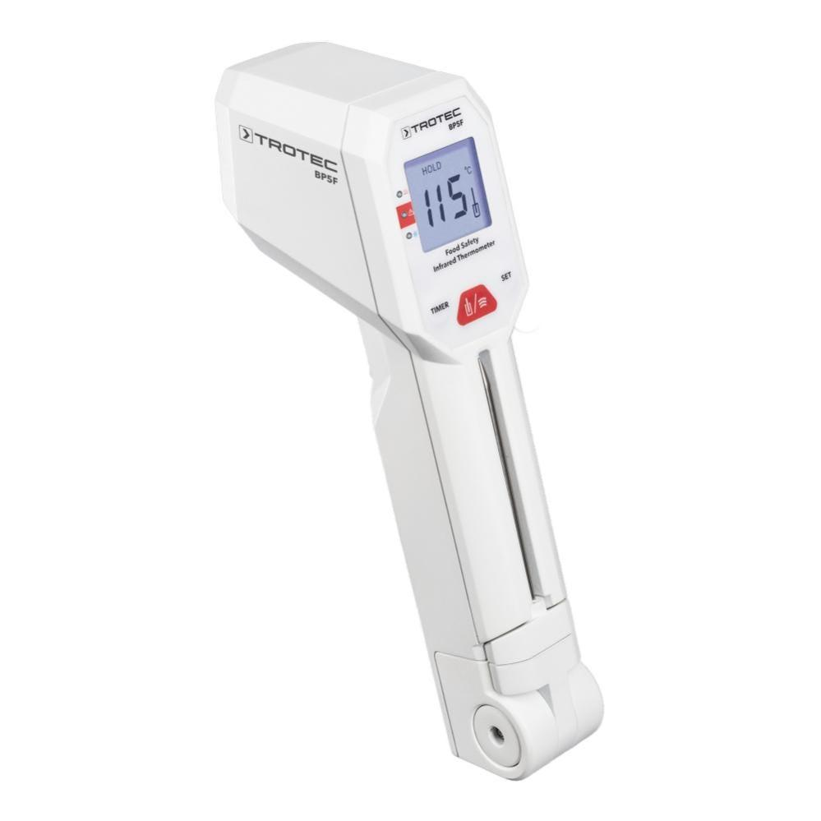
Description
Designed for measuring the surface temperature of food during cooking, storage, and inspection.
Features
- Instant readings
- Non-contact
- Food-safe operation
Applications
- Restaurants
- Commercial kitchens
- Food processing
- Food safety inspections

6. High-Temperature Infrared Thermometer (Pyrometer)
# Source: AI Source: Provided by: [Data Path: Persons Table -> ID Column: 1, Name_En Column: Motasem Essam] -> From: [ChatGPT] on [7/17/2026]
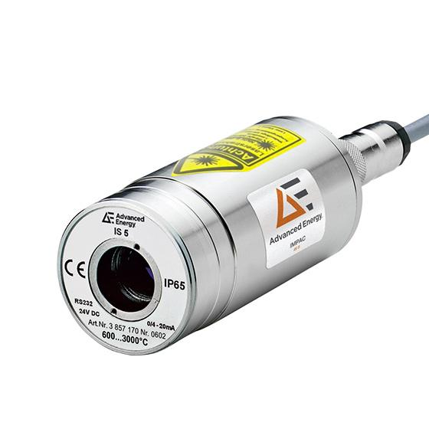
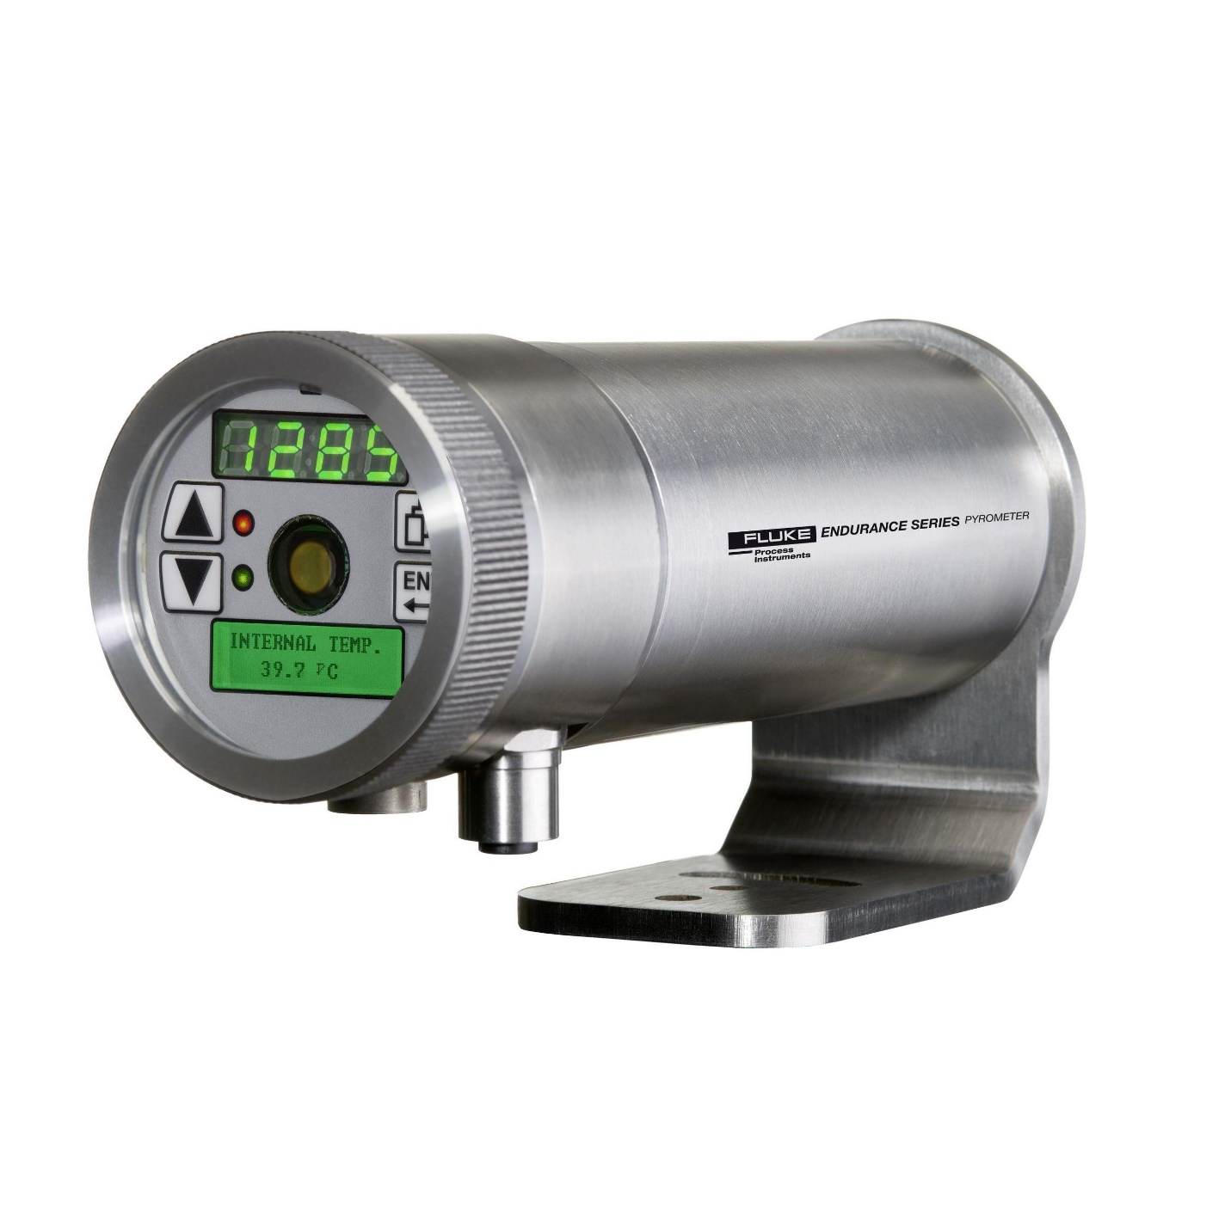
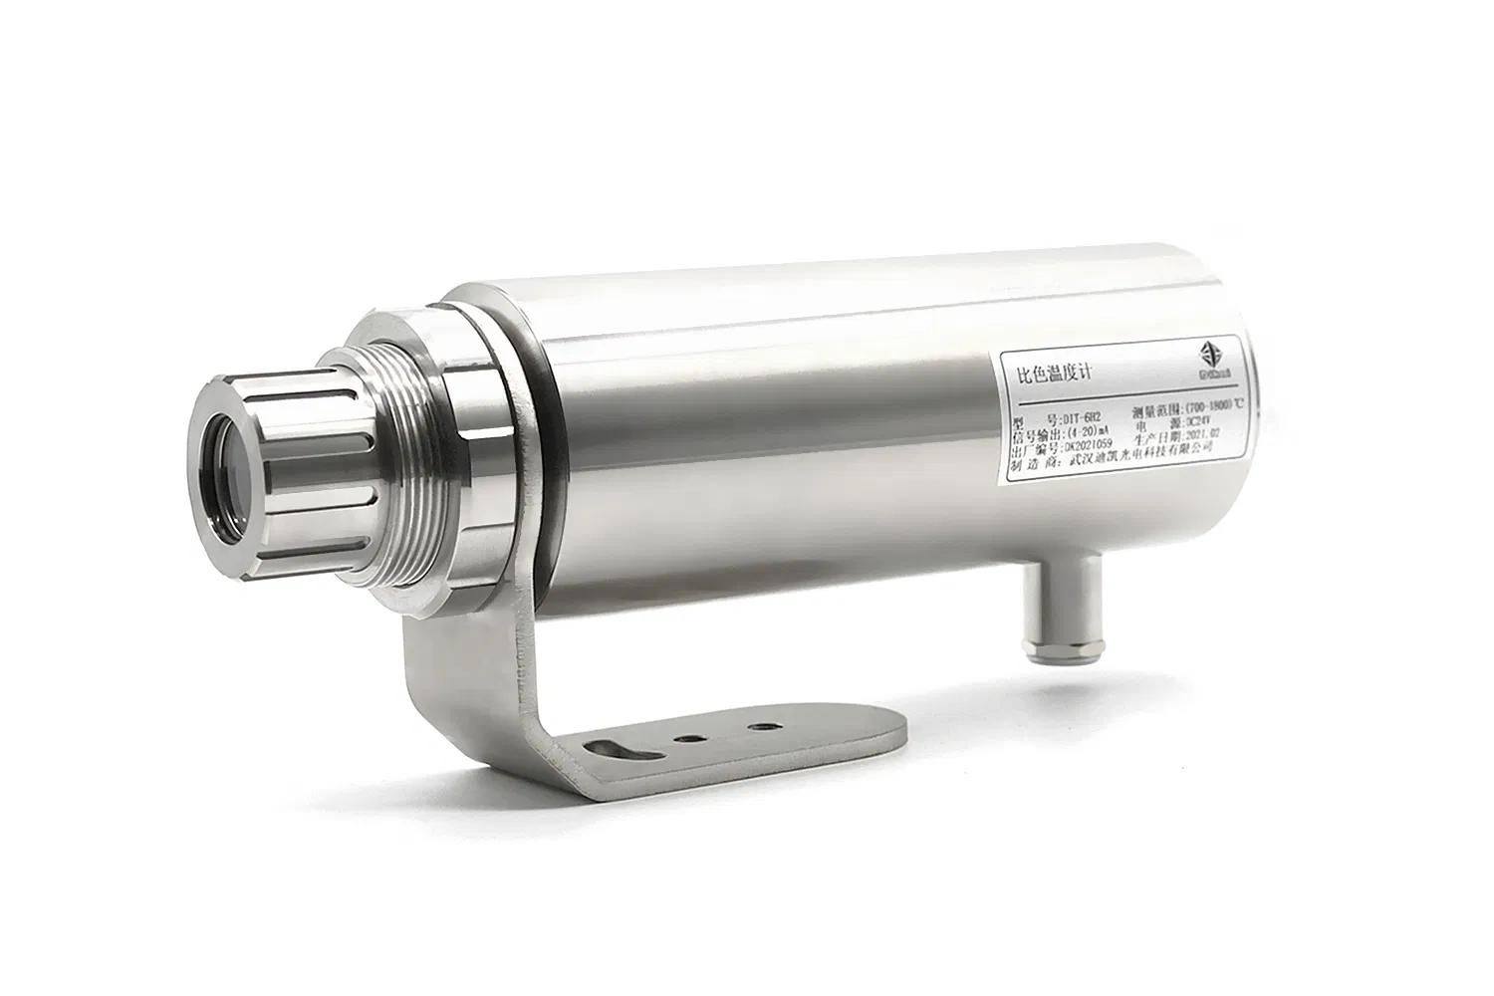
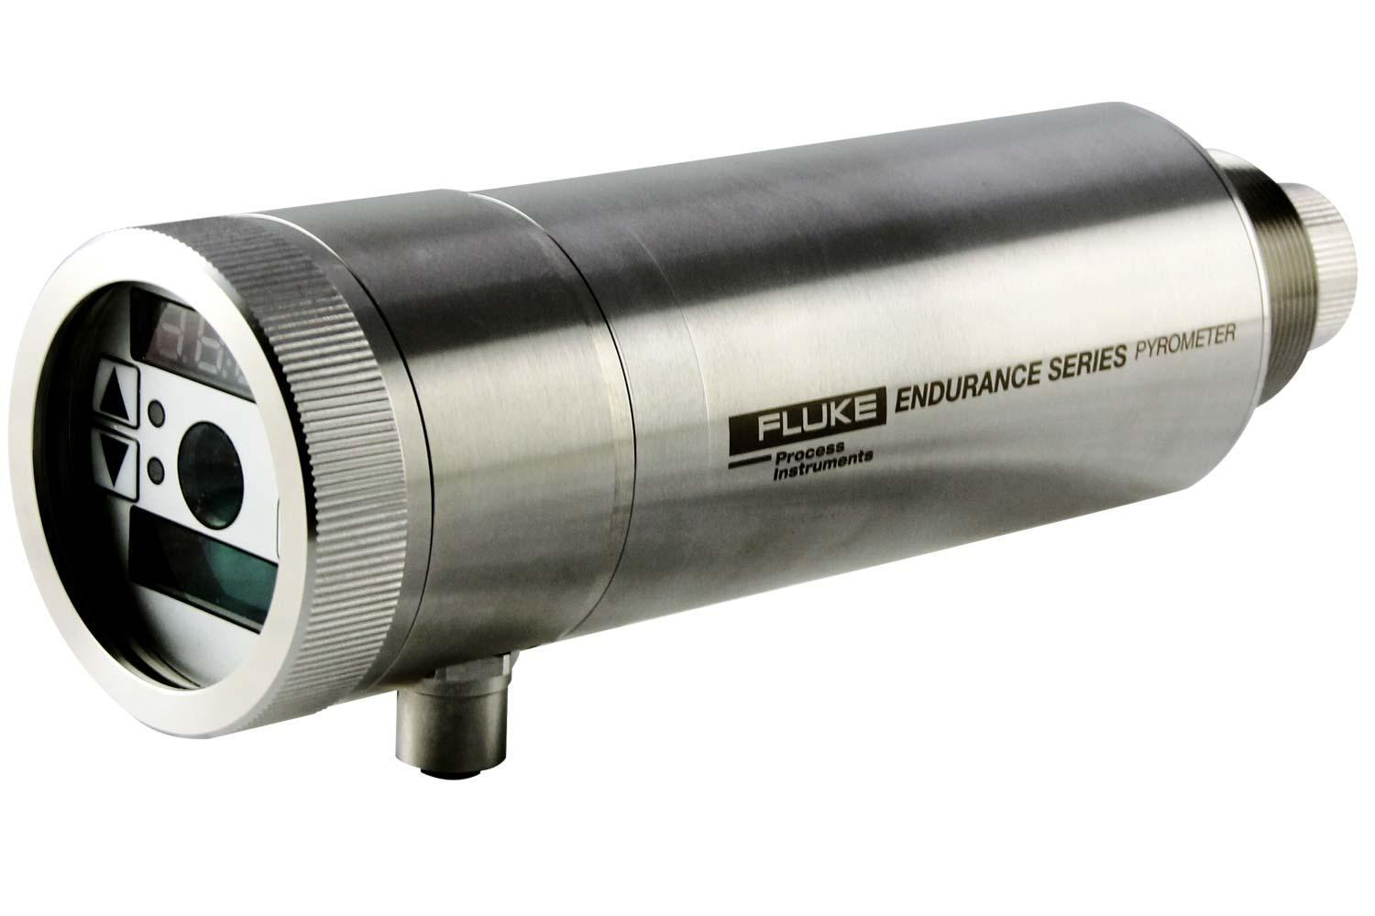
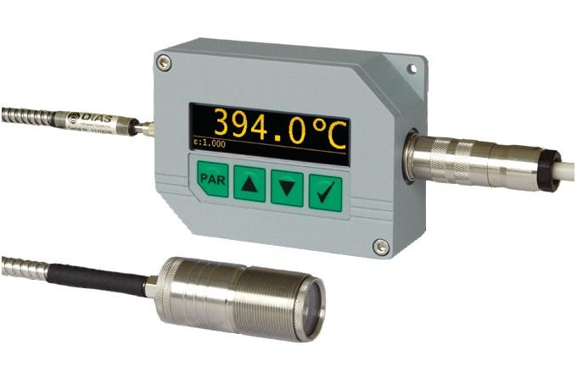
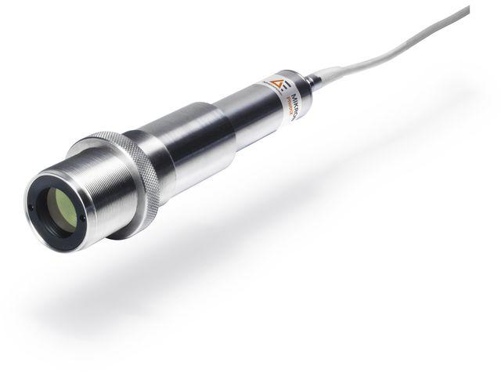
Description
Specialized infrared thermometer designed to measure very high temperatures that cannot be safely measured using contact thermometers.
Features
- Extremely wide measuring range
- Long-distance measurement
- Industrial-grade construction
Applications
- Steel industry
- Glass manufacturing
- Foundries
- Furnaces
- Kilns
- Metallurgy

Measuring Units
# Source: AI Source: Provided by: [Data Path: Persons Table -> ID Column: 1, Name_En Column: Motasem Essam] -> From: [ChatGPT] on [7/17/2026]
Infrared thermometers commonly display:
- Degrees Celsius (°C)
- Degrees Fahrenheit (°F)
Some industrial systems may also report:
- Kelvin (K)

Measuring Range
# Source: AI Source: Provided by: [Data Path: Persons Table -> ID Column: 1, Name_En Column: Motasem Essam] -> From: [ChatGPT] on [7/17/2026]
The measuring range depends on the application.
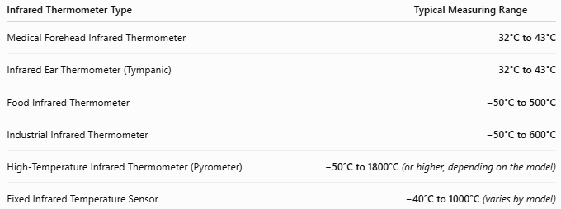
Infrared Thermometer Type | Typical Measuring Range
Medical Forehead Infrared Thermometer | 32°C to 43°C
Infrared Ear Thermometer (Tympanic) | 32°C to 43°C
Food Infrared Thermometer | −50°C to 500°C
Industrial Infrared Thermometer | −50°C to 600°C
High-Temperature Infrared Thermometer (Pyrometer) | −50°C to 1800°C (or higher, depending on the model)
Fixed Infrared Temperature Sensor | −40°C to 1000°C (varies by model)

Resolution
# Source: AI Source: Provided by: [Data Path: Persons Table -> ID Column: 1, Name_En Column: Motasem Essam] -> From: [ChatGPT] on [7/17/2026]
Typical resolution:
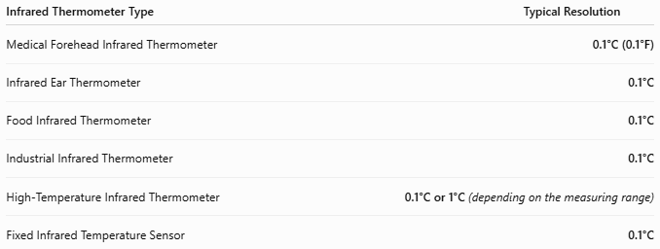
Infrared Thermometer Type | Typical Resolution
Medical Forehead Infrared Thermometer | 0.1°C (0.1°F)
Infrared Ear Thermometer | 0.1°C
Food Infrared Thermometer | 0.1°C
Industrial Infrared Thermometer | 0.1°C
High-Temperature Infrared Thermometer | 0.1°C or 1°C (depending on the measuring range)
Fixed Infrared Temperature Sensor | 0.1°C

Accuracy
# Source: AI Source: Provided by: [Data Path: Persons Table -> ID Column: 1, Name_En Column: Motasem Essam] -> From: [ChatGPT] on [7/17/2026]
Typical accuracy:
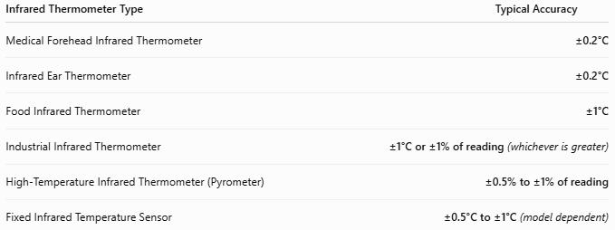
Infrared Thermometer Type | Typical Accuracy
Medical Forehead Infrared Thermometer | ±0.2°C
Infrared Ear Thermometer | ±0.2°C
Food Infrared Thermometer | ±1°C
Industrial Infrared Thermometer | ±1°C or ±1% of reading (whichever is greater)
High-Temperature Infrared Thermometer (Pyrometer) | ±0.5% to ±1% of reading
Fixed Infrared Temperature Sensor | ±0.5°C to ±1°C (model dependent)

How to Use an Infrared Thermometer
# Source: AI Source: Provided by: [Data Path: Persons Table -> ID Column: 1, Name_En Column: Motasem Essam] -> From: [ChatGPT] on [7/17/2026]
- Turn the thermometer on.
- Select the desired mode (body or surface, if available).
- Aim the sensor at the target.
- Maintain the recommended measuring distance.
- Press the trigger or measurement button.
- Read the displayed temperature.

Distance-to-Spot Ratio (D:S Ratio)
# Source: AI Source: Provided by: [Data Path: Persons Table -> ID Column: 1, Name_En Column: Motasem Essam] -> From: [ChatGPT] on [7/17/2026]
The Distance-to-Spot (D:S) Ratio indicates the relationship between the measuring distance and the diameter of the area being measured.
Example:
A 12:1 D:S ratio means:
- At 12 cm, the thermometer measures a spot approximately 1 cm in diameter.
- At 120 cm, it measures a spot approximately 10 cm in diameter.
Higher D:S ratios allow accurate measurement from greater distances.

Emissivity
# Source: AI Source: Provided by: [Data Path: Persons Table -> ID Column: 1, Name_En Column: Motasem Essam] -> From: [ChatGPT] on [7/17/2026]
Different materials emit different amounts of infrared radiation.
This property is called emissivity (ε).
Many industrial infrared thermometers allow emissivity adjustment.
Typical emissivity values:
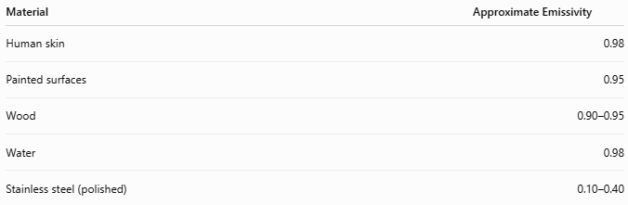
Material | Approximate Emissivity
Human skin | 0.98
Painted surfaces | 0.95
Wood | 0.90–0.95
Water | 0.98
Stainless steel (polished) | 0.10–0.40
Incorrect emissivity settings can introduce measurement errors.

Example
# Source: AI Source: Provided by: [Data Path: Persons Table -> ID Column: 1, Name_En Column: Motasem Essam] -> From: [ChatGPT] on [7/17/2026]
The display reads:
75.3°C
Measured surface temperature:
75.3°C

Applications
# Source: AI Source: Provided by: [Data Path: Persons Table -> ID Column: 1, Name_En Column: Motasem Essam] -> From: [ChatGPT] on [7/17/2026]
Infrared thermometers are used in:
- Hospitals
- Medical clinics
- Manufacturing
- HVAC systems
- Electrical maintenance
- Mechanical maintenance
- Food safety inspections
- Refrigeration
- Automotive diagnostics
- Scientific laboratories

Advantages
# Source: AI Source: Provided by: [Data Path: Persons Table -> ID Column: 1, Name_En Column: Motasem Essam] -> From: [ChatGPT] on [7/17/2026]
An infrared thermometer:
- Measures temperature without contact.
- Produces almost instantaneous readings.
- Is safe for hot, moving, or hazardous objects.
- Reduces contamination risk.
- Measures inaccessible surfaces.
- Is easy to operate.

Limitations
# Source: AI Source: Provided by: [Data Path: Persons Table -> ID Column: 1, Name_En Column: Motasem Essam] -> From: [ChatGPT] on [7/17/2026]
An infrared thermometer:
- Measures surface temperature only.
- Cannot measure internal temperature directly.
- Accuracy depends on emissivity.
- Steam, smoke, dust, and reflective surfaces can affect measurements.
- Medical models are not interchangeable with industrial models.

Sources of Error
# Source: AI Source: Provided by: [Data Path: Persons Table -> ID Column: 1, Name_En Column: Motasem Essam] -> From: [ChatGPT] on [7/17/2026]
Instrument Errors
- Incorrect calibration
- Dirty lens
- Low battery

User Errors
- Incorrect measuring distance
- Measuring too large a target area
- Improper aiming
- Wrong emissivity setting

Environmental Errors
- Steam
- Dust
- Smoke
- Direct sunlight
- Reflective metal surfaces

Comparison with Other Temperature Measuring Instruments
# Source: AI Source: Provided by: [Data Path: Persons Table -> ID Column: 1, Name_En Column: Motasem Essam] -> From: [ChatGPT] on [7/17/2026]
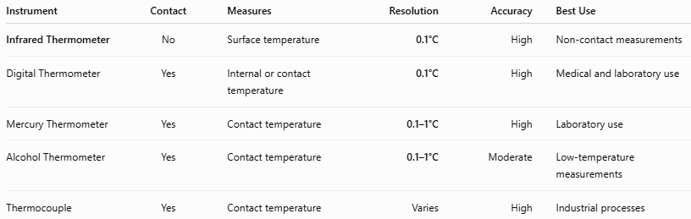
Instrument | Contact | Measures | Resolution | Accuracy | Best Use
Infrared Thermometer | No | Surface temperature | 0.1°C | High | Non-contact measurements
Digital Thermometer | Yes | Internal or contact temperature | 0.1°C | High | Medical and laboratory use
Mercury Thermometer | Yes | Contact temperature | 0.1–1°C | High | Laboratory use
Alcohol Thermometer | Yes | Contact temperature | 0.1–1°C | Moderate | Low-temperature measurements
Thermocouple | Yes | Contact temperature | Varies | High | Industrial processes

Care and Maintenance
# Source: AI Source: Provided by: [Data Path: Persons Table -> ID Column: 1, Name_En Column: Motasem Essam] -> From: [ChatGPT] on [7/17/2026]
To maintain accuracy:
- Keep the lens clean.
- Replace batteries as required.
- Avoid dropping the instrument.
- Store in a protective case.
- Calibrate periodically.
- Protect from excessive humidity and dust.

Common Mistakes
# Source: AI Source: Provided by: [Data Path: Persons Table -> ID Column: 1, Name_En Column: Motasem Essam] -> From: [ChatGPT] on [7/17/2026]
- Measuring through glass (most IR thermometers measure the glass surface, not objects behind it).
- Ignoring the recommended measuring distance.
- Using incorrect emissivity settings.
- Measuring shiny metal without emissivity correction.
- Assuming it measures internal temperature.

Key Points
# Source: AI Source: Provided by: [Data Path: Persons Table -> ID Column: 1, Name_En Column: Motasem Essam] -> From: [ChatGPT] on [7/17/2026]
- An Infrared Thermometer measures surface temperature without physical contact.
- Common types:
  - Medical Forehead Infrared Thermometer
  - Infrared Ear Thermometer
  - Industrial Infrared Thermometer
  - Fixed Infrared Temperature Sensor
- Common units:
  - °C
  - °F
- Uses infrared radiation instead of direct contact.
- Widely used in medicine, industry, maintenance, food safety, and scientific applications.

Conclusion
# Source: AI Source: Provided by: [Data Path: Persons Table -> ID Column: 1, Name_En Column: Motasem Essam] -> From: [ChatGPT] on [7/17/2026]
An Infrared Thermometer is a modern, non-contact temperature-measuring instrument that determines surface temperature by sensing the infrared radiation naturally emitted by objects. Its speed, safety, and ability to measure temperatures from a distance make it indispensable in medical screening, industrial maintenance, electrical inspections, food safety, HVAC systems, and scientific research. Although highly versatile, proper use—including correct distance, target selection, and emissivity settings—is essential to achieve accurate and reliable measurements.

